# PROPOSAL

# WHICH IS IT?

# Do Fatal Overdoses, ER Visits Rise With Unemployment Rate?

**Owl Project 2 Team:**

Hubert Cheng,

Charles Dixon

Sujin Guo

Mark Yocum

*By*[*Victoria Kim*](https://www.thefix.com/bio/victoria-kim)*04/20/17*

The link between economic hardship and drug overdoses is being studied by a team of researchers.



What’s fueling the rise in opioid deaths? A [recent report](https://www.theatlantic.com/health/archive/2017/04/joblessness-and-opioids/523281/) by Olga Khazan for *The Atlantic* points to economic reasons—namely, unemployment.

A [study published this month](http://papers.nber.org/tmp/82064-w23192.pdf) in the National Bureau of Economic Research (NBER) showed that in a given county, as the unemployment rate grows by 1 percentage point, the rate of opioid deaths grows by 3.6% and emergency room visits increase by 7%.

# OR

# Have Blue-Collar Workers Disappeared as a Result of Drug Overdoses?

[](https://www.forbes.com/sites/kenrapoza/)

[**Kenneth Rapoza**](https://www.forbes.com/sites/kenrapoza/)

Senior Contributor

[Markets](https://www.forbes.com/markets)*I write about business and investing in emerging markets.*

##### TWEET THIS

* [The Conference Board said companies will have to relocate to areas with a greater availability of blue-collar workers.](https://twitter.com/intent/tweet?url=http%3A%2F%2Fwww.forbes.com%2Fsites%2Fkenrapoza%2F2018%2F12%2F16%2Fin-2019-blue-collar-workers-disappearing-and-in-hot-demand%2F&text=The%20Conference%20Board%20said%20companies%20will%20have%20to%20relocate%20to%20areas%20with%20a%20greater%20availability%20of%20blue-collar%20workers.)
* [Although the U.S. economy will slow, 2019 will not be easier on companies dependent on blue-collar workers.](https://twitter.com/intent/tweet?url=http%3A%2F%2Fwww.forbes.com%2Fsites%2Fkenrapoza%2F2018%2F12%2F16%2Fin-2019-blue-collar-workers-disappearing-and-in-hot-demand%2F&text=Although%20the%20U.S.%20economy%20will%20slow%2C%202019%20will%20not%20be%20easier%20on%20companies%20dependent%20on%20blue%20collar%20workers.)

# Our Data and the Links

From the Bureau of Labor and Statistics

<https://www.bls.gov/data/#api>

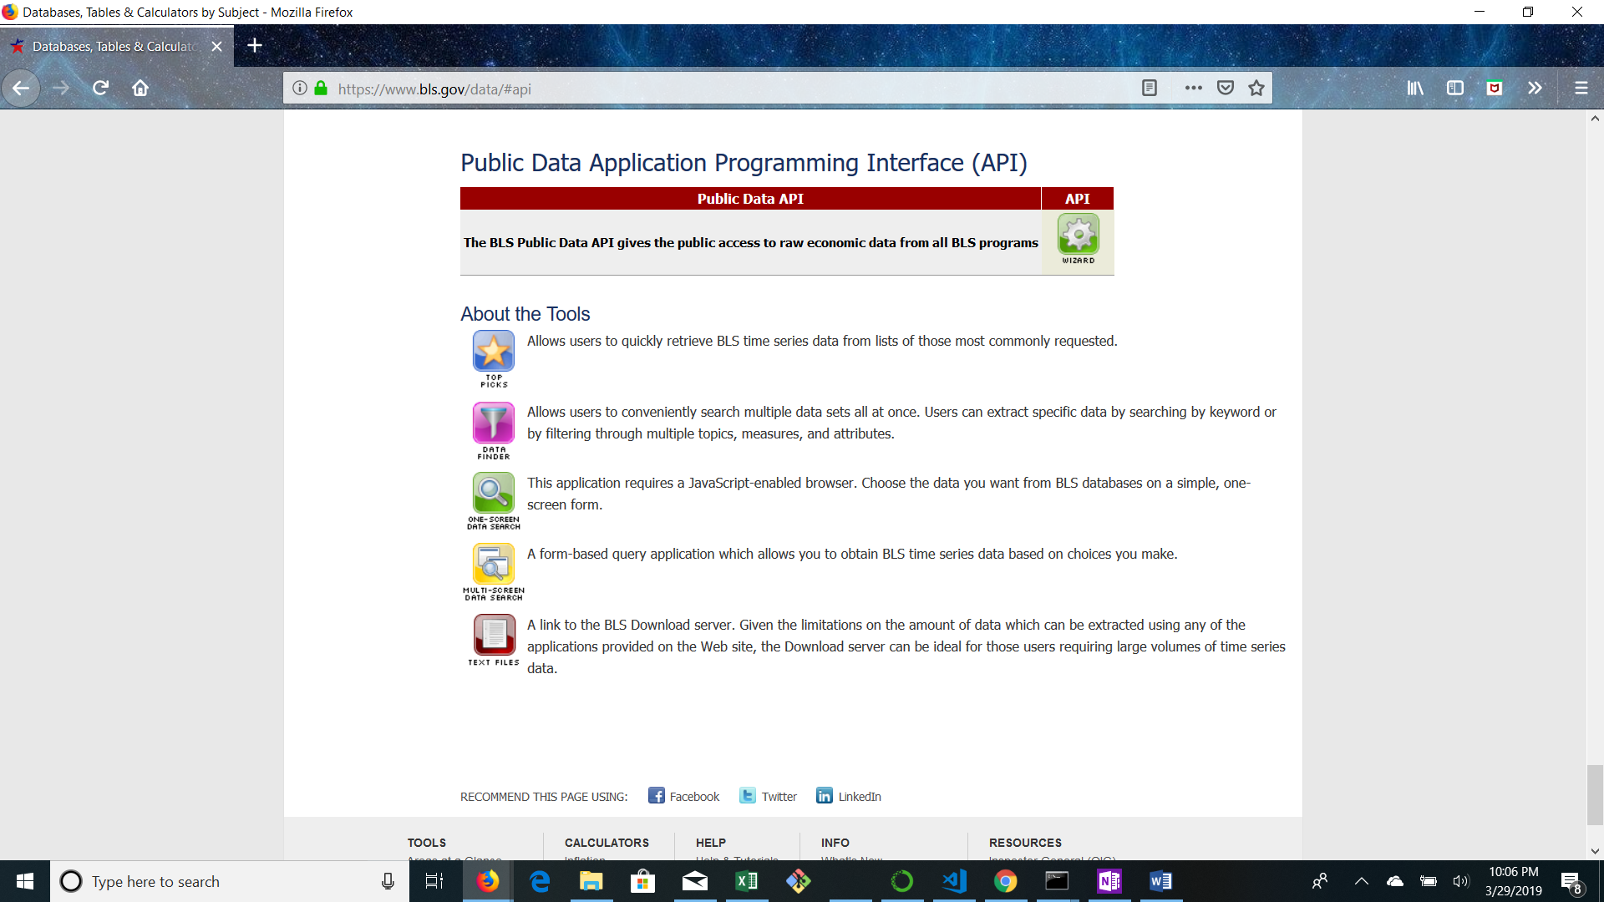

National Center for Health Statistics

<https://www.cdc.gov/nchs/nvss/vsrr/drug-overdose-data.htm>

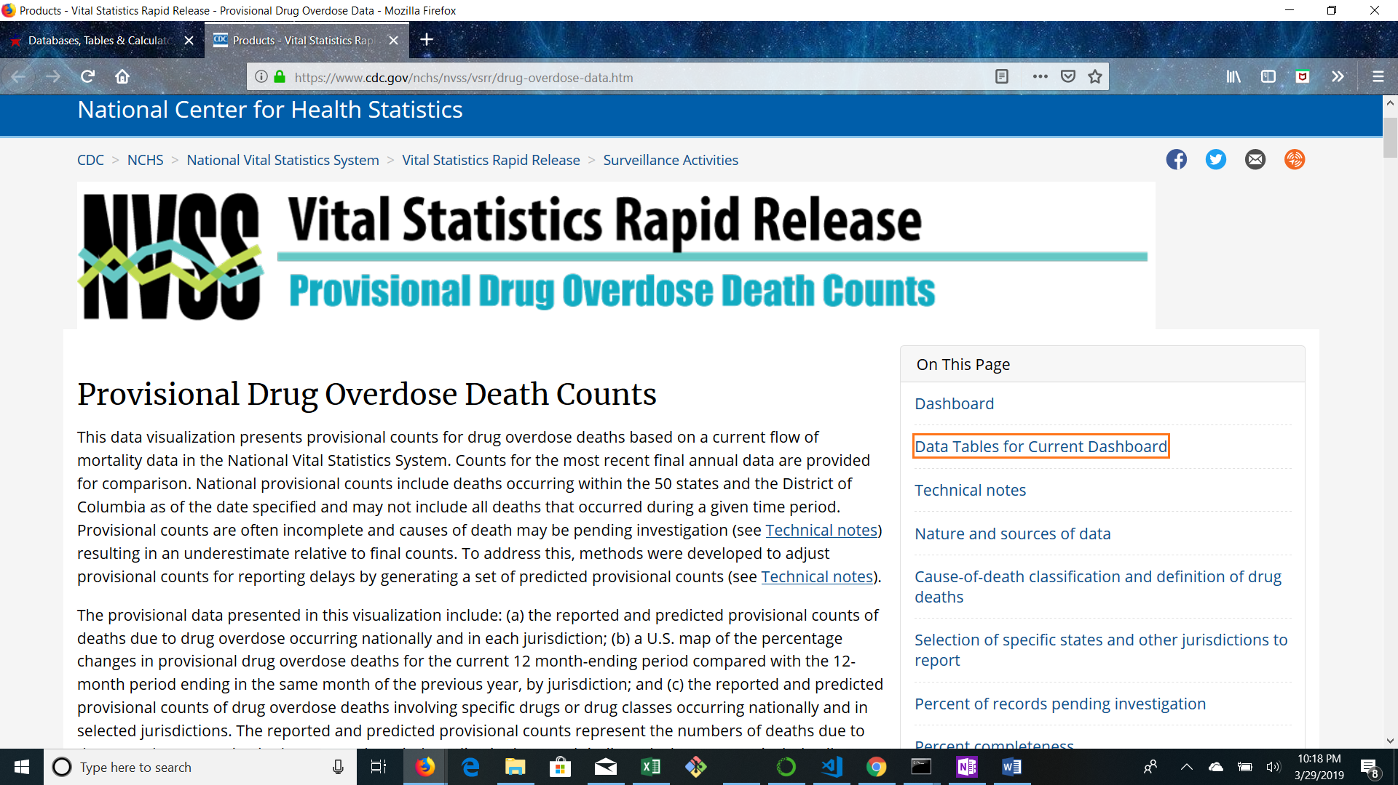

A link to our primary GitHub repository:

<https://github.com/Sujin-owl/Project2>

Screen Shots of Relevant Inspiring Visualizations:

